|  |  |
| --- | --- |
| **Objective :** | ***To become familiar with JDBC Connectivity & manipulating DB queries through java.*** |

***LAB # 8***

* ***TASKS:***

1. ***Insert 10 different records in student table and show on console whether all records are successfully inserted or not.***

***Program:***

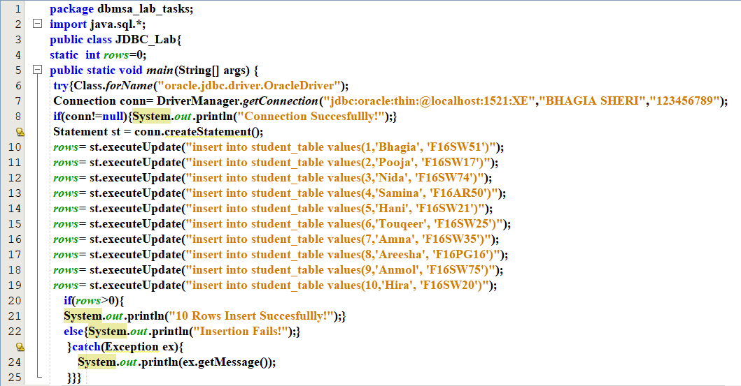

***Output:***

1. ***Select any 2 records and print them on the console.***

***Program:***

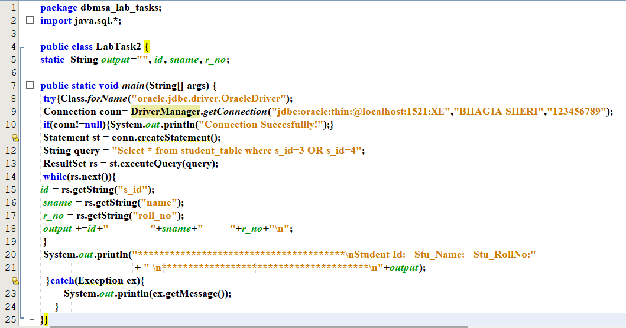

***Output:***

1. ***Update one record and display their success on console.***

***Program:***

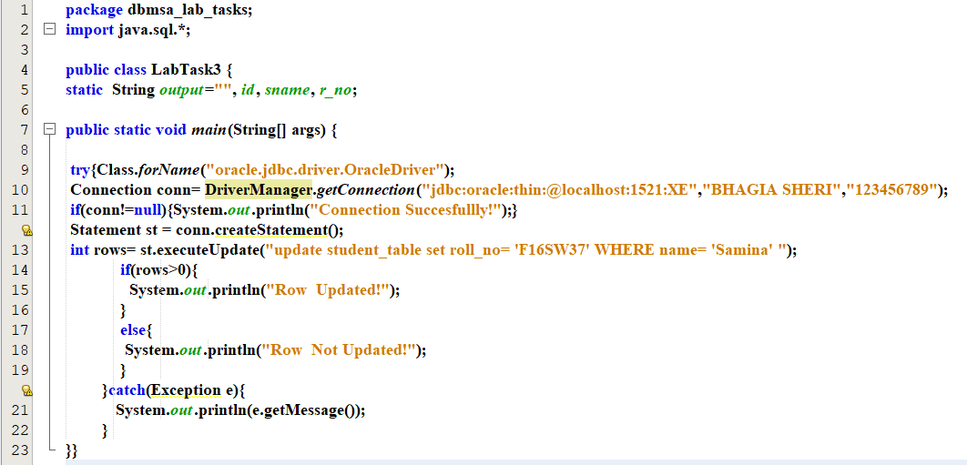

***Output:***

1. ***Select the updated record and print them on the console.***

***Program:***

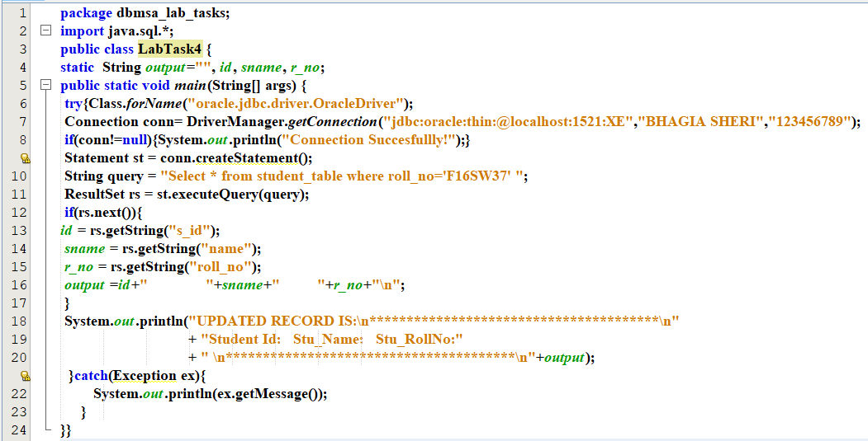

***Output:***

1. ***Delete the updated record and display its success on console.***

***Program:***

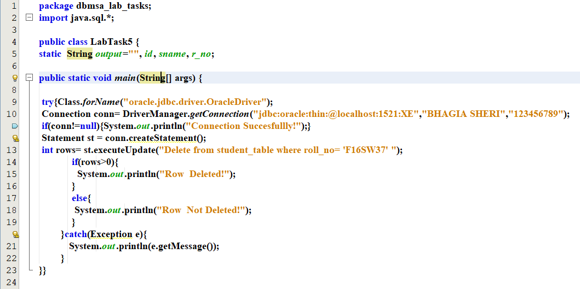

***Output:***

1. ***Select all the records and print them on console.***

***Program:***

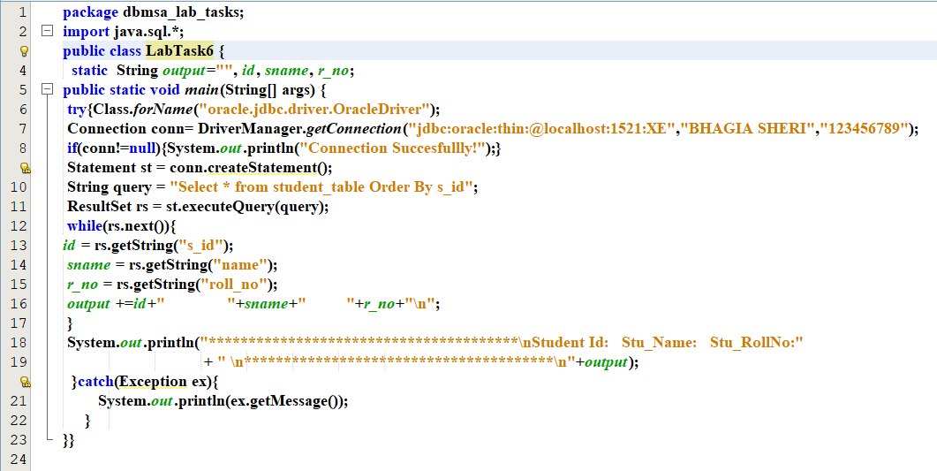

***Output:***